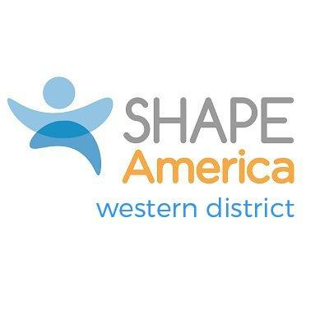
WESTERN DISTRICT SCHOLAR AWARD
Nominations by September 15
Applications by October 15
Return to District Awards Chair: See SHAPE America Western District webpage

Description:
This award recognizes individuals from the Western District (WD) who enrich the depth and scope of health, leisure, sport, and movement-related activities by generating research and disseminating findings to the profession and the public. The award can be given annually at a WD-sponsored/co-sponsored conference or workshop, or at the state conference of the candidate of each year. The qualifying criterion for this award includes:

- SHAPE America Membership: The nominee shall have been a member of SHAPE America for a minimum of five years, including the year he/she is considered for the award. (Former SHAPE America members who have retired from the profession are exempt from this requirement.)

- Character: Ethical behavior consistent with the accepted ideals of the profession.

- Service: Candidates should show evidence of research or scholarly activity, service and a commitment to the profession. Successful recipients of the award should meet at least one criterion under each of the three categories below. The following are the categories and some illustrations of contributions:

- Publications
- Articles in a variety of professional and/or popular publications;
- Author or co-author of texts endorsed by professional colleagues;
- Research articles published in recognized journals.

- Public Service and Leadership
- Conference speeches, keynote addresses, etc.;
- Being sought for consultation;
- Diverse and practical service activities with documentation of involvement;

- Professional Commitment
- Contributor to SHAPE America publications;
- Service on national, district or state committees;
- Demonstrated expertise in the research process with sophistication as either a proficient researcher or competent critic of research.

Western District Scholar Award
Candidate Application
Due by October 15
Return to District Awards Chair: See SHAPE America Western District webpage

Name of candidate:

College/University Organizational head contact information:

Local media outlet contact information:

Criteria: Membership- Must be a SHAPE America Member for at least 5 years
SHAPE America membership number: __________________

Length of time as a SHAPE America member:____________

Other professional organizational membership(s) or certifications:

- Criteria: Character Provide two letters of support, with at least one from the applicant’s administrator or colleague. The letter should be directly related to the award qualifications providing a biographical sketch outlining the contributions of the applicant and how those contributions are deserving of recognition.

- Criteria: Service Provide information of at least one instance in each category that you displayed evidence of research or scholarly activity, service AND distinctive leadership, and meritorious service to the profession. (See the award’s description for more information).

PUBLICATIONS

PUBLIC SERVICE AND LEADERSHIP

PROFESSIONAL COMMITMENT

